

Capstone Project Report

E-Governance Grievance Redressal System
By : Debarghya Sikder

The following document contains the description and explanation of the project E-Governance Grievance Redressal System. This project has all the required requirements of the project. The project has been developed using SpringBoot 3.5.9 , Angular 21, Docker, JUnit.

INDEX

1. Project Over View

2. Architecture Diagram

3. SonarQube Report

4. Postman Screenshots
5. Angular Frontend

1. Project Overview
Government departments receive a large number of citizen grievances related to public services, which are often processed through manual or semi-manual methods. These traditional approaches lead to delays, limited visibility into grievance status, and reduced accountability. The E-Governance Grievance Redressal System addresses these challenges by providing a centralized, technology-driven platform for efficient grievance management.
The proposed E-Governance Grievance Redressal System is a centralized, web-based Java application that enables citizens to submit grievances online and track their progress in real time. The system automatically routes complaints to the appropriate departments, manages the complete grievance lifecycle, and provides dashboards and status updates to enhance transparency, accountability, and timely resolution.
The scope of the system includes online grievance registration, automated assignment to concerned departments, status tracking, escalation handling, and resolution of grievances across multiple government departments, ensuring improved service delivery and citizen satisfaction.

There are 5 user roles -
- Citizen - Submits and tracks grievances
- Admin - Managers staff users, manages departments
- Department Officer - Each department has multiple officers who manages grievances. The grievances are auto assigned to them.
- Supervisory Officer - View and Handle Escalations

Architecture Diagram
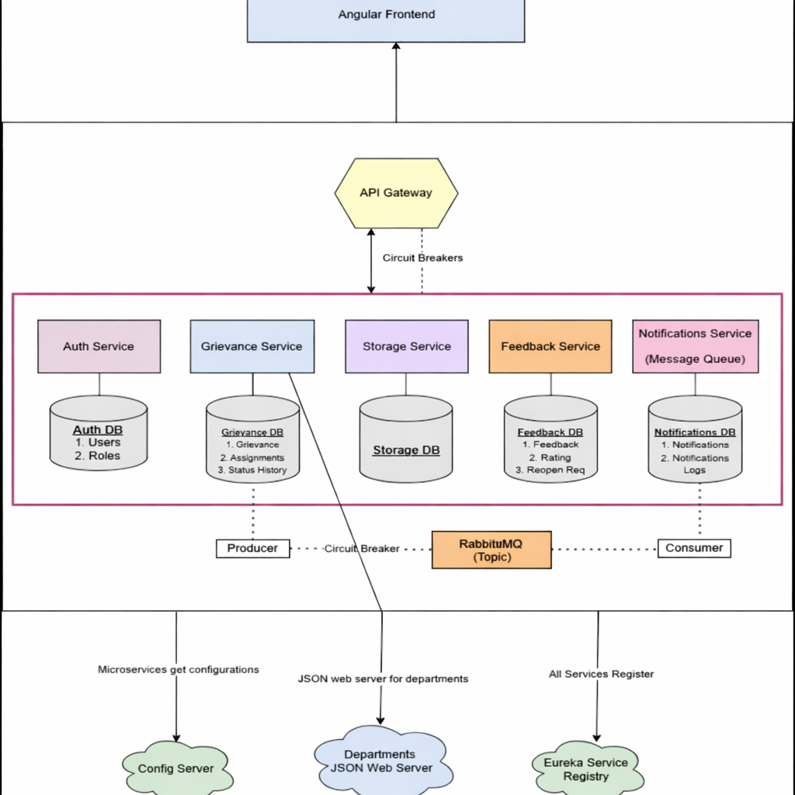

This web application has 4 core microservices Auth Service, Grievance Service (Internal Storage DB), Feedback Service and Notifications Service

To store departments a JSON server is used. These services talk to each other through API Gateway by registering themselves on Eureka Server.

3. Sonarqube Report & Unit Testing

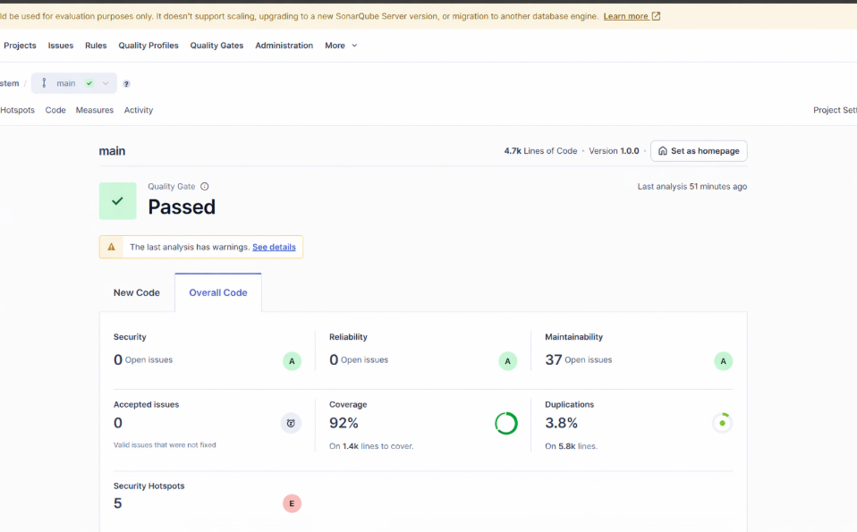

4. Postman Screenshots
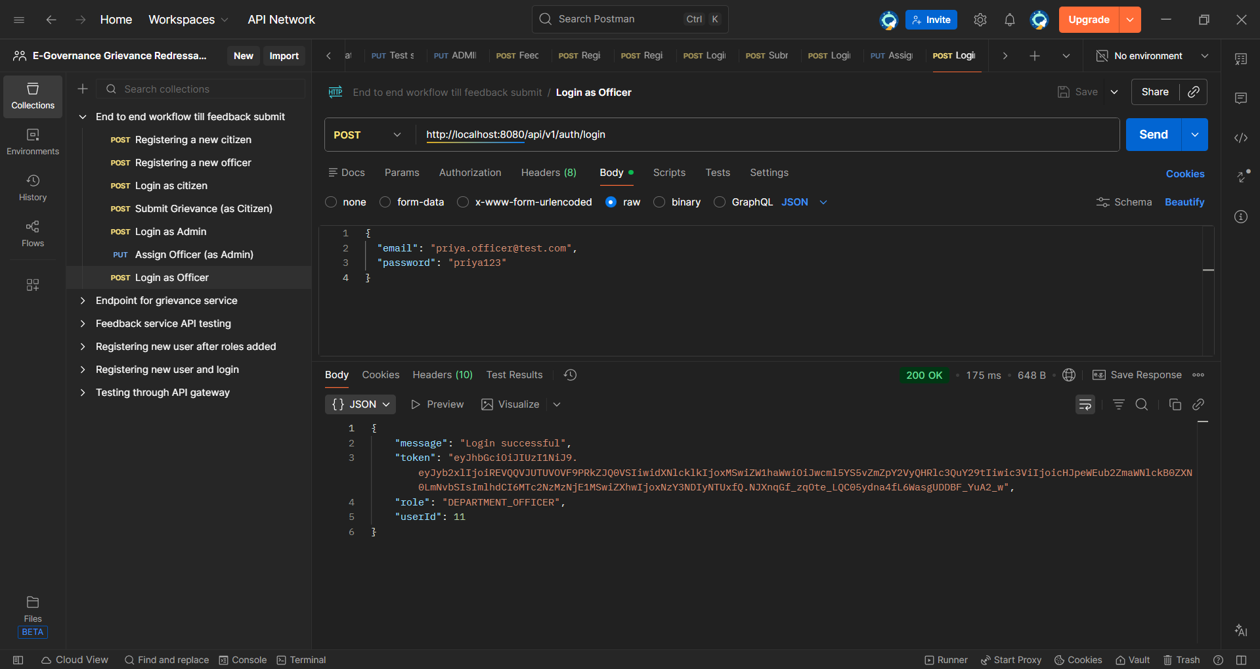
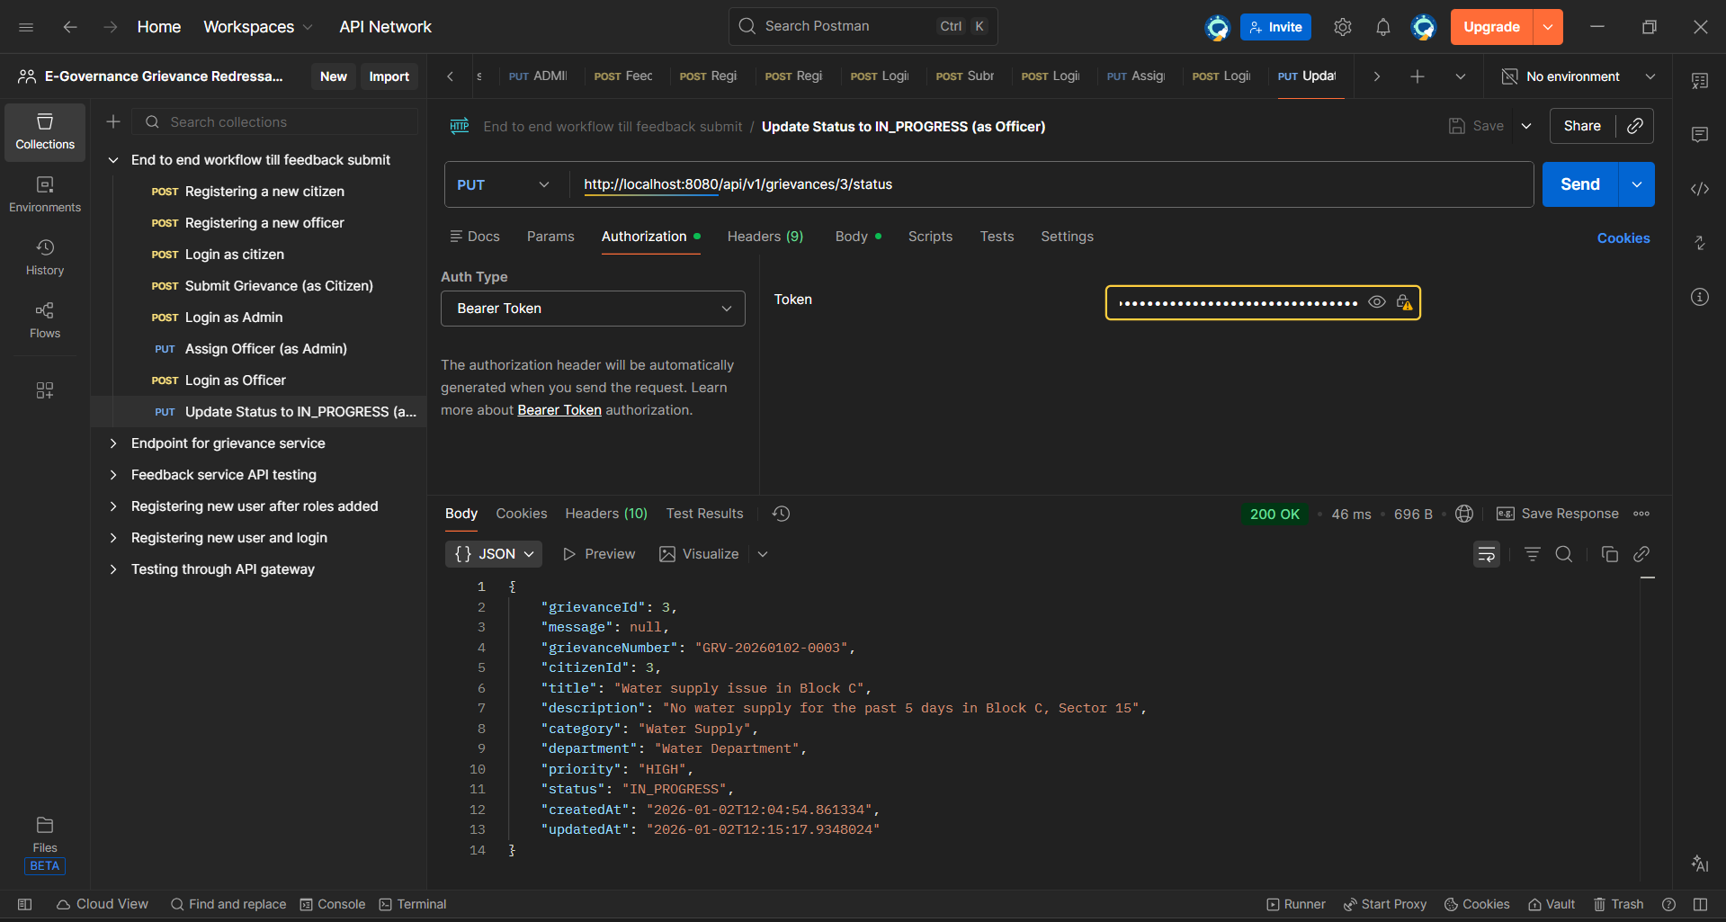

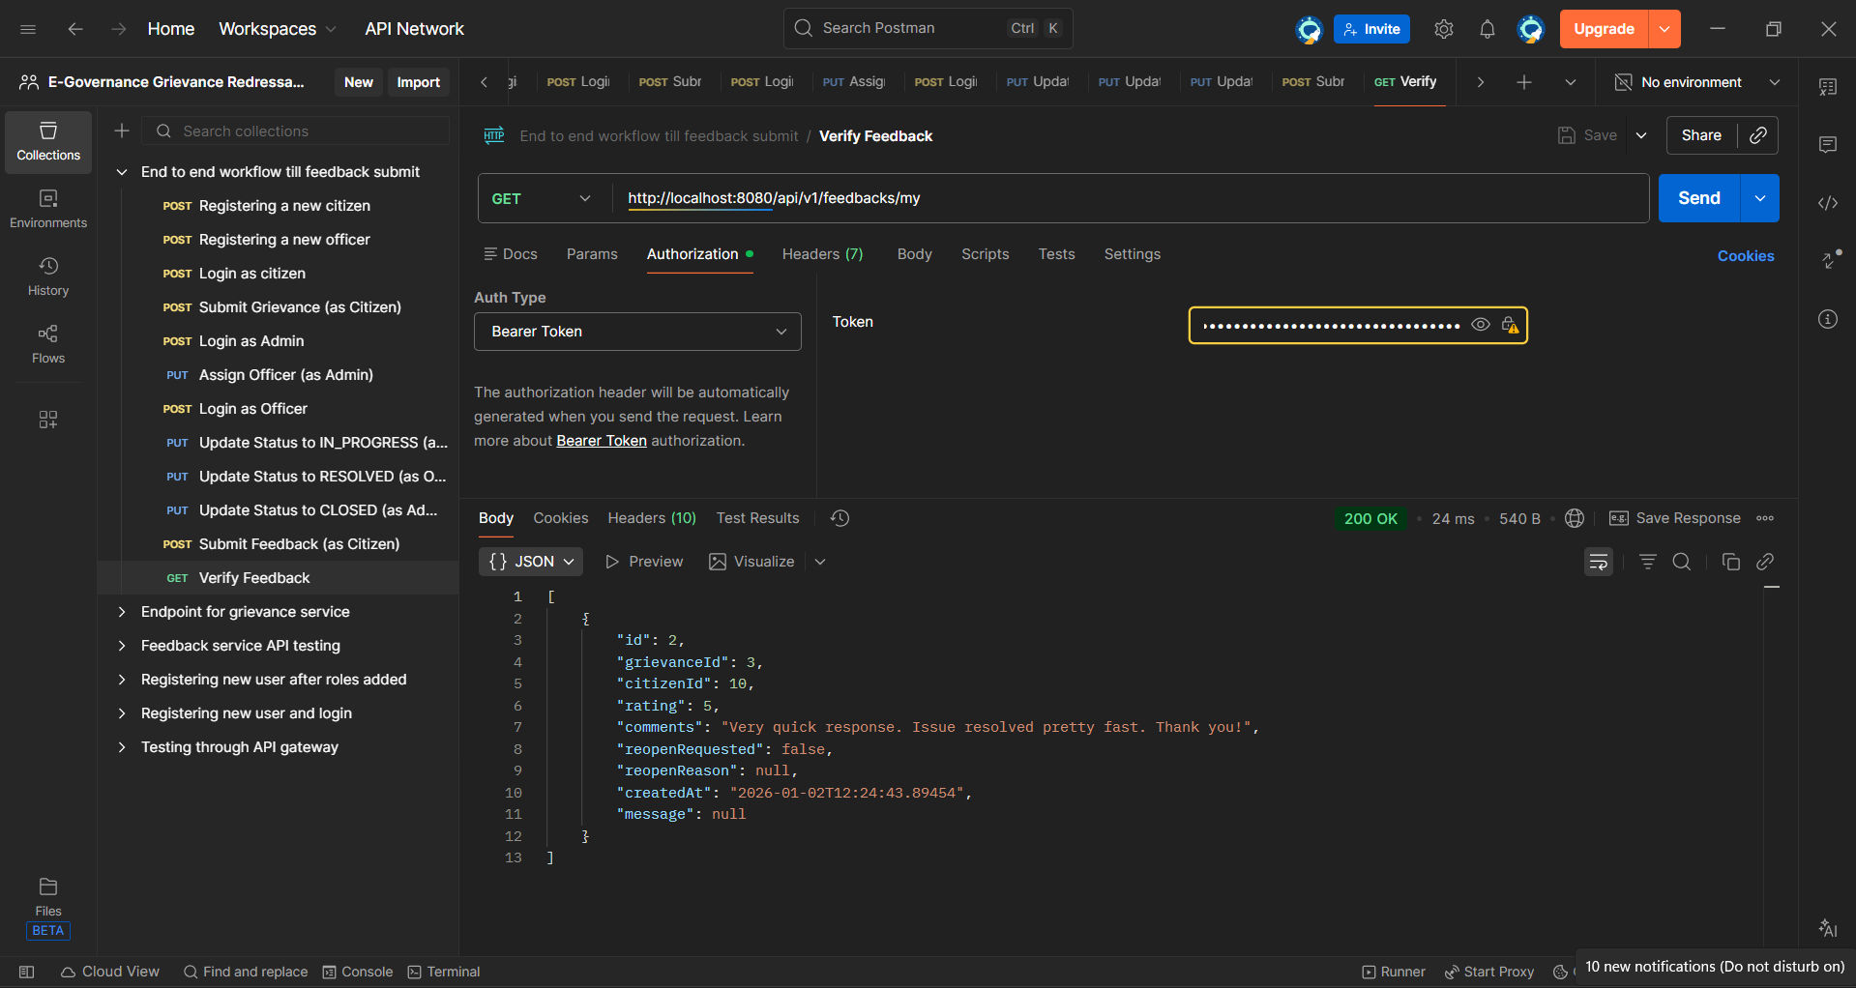

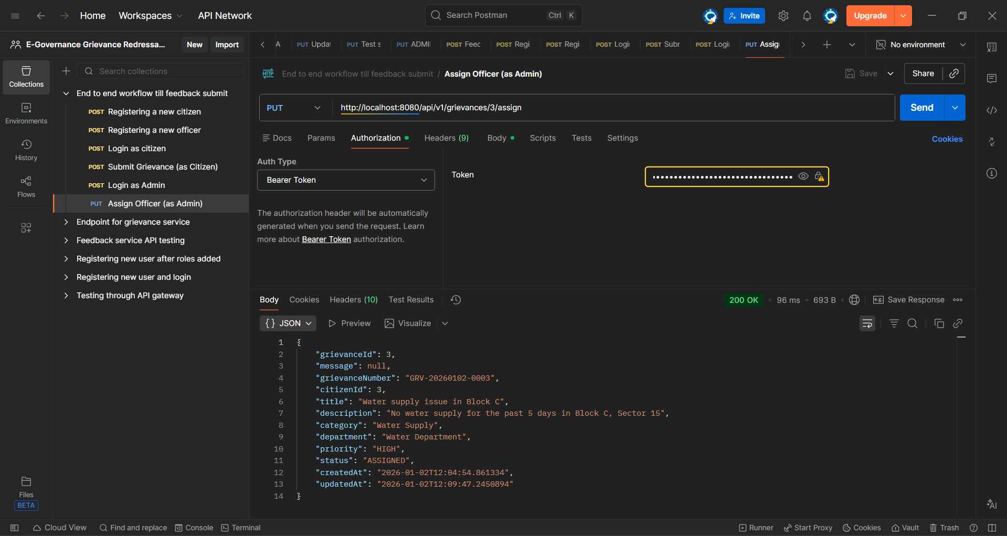

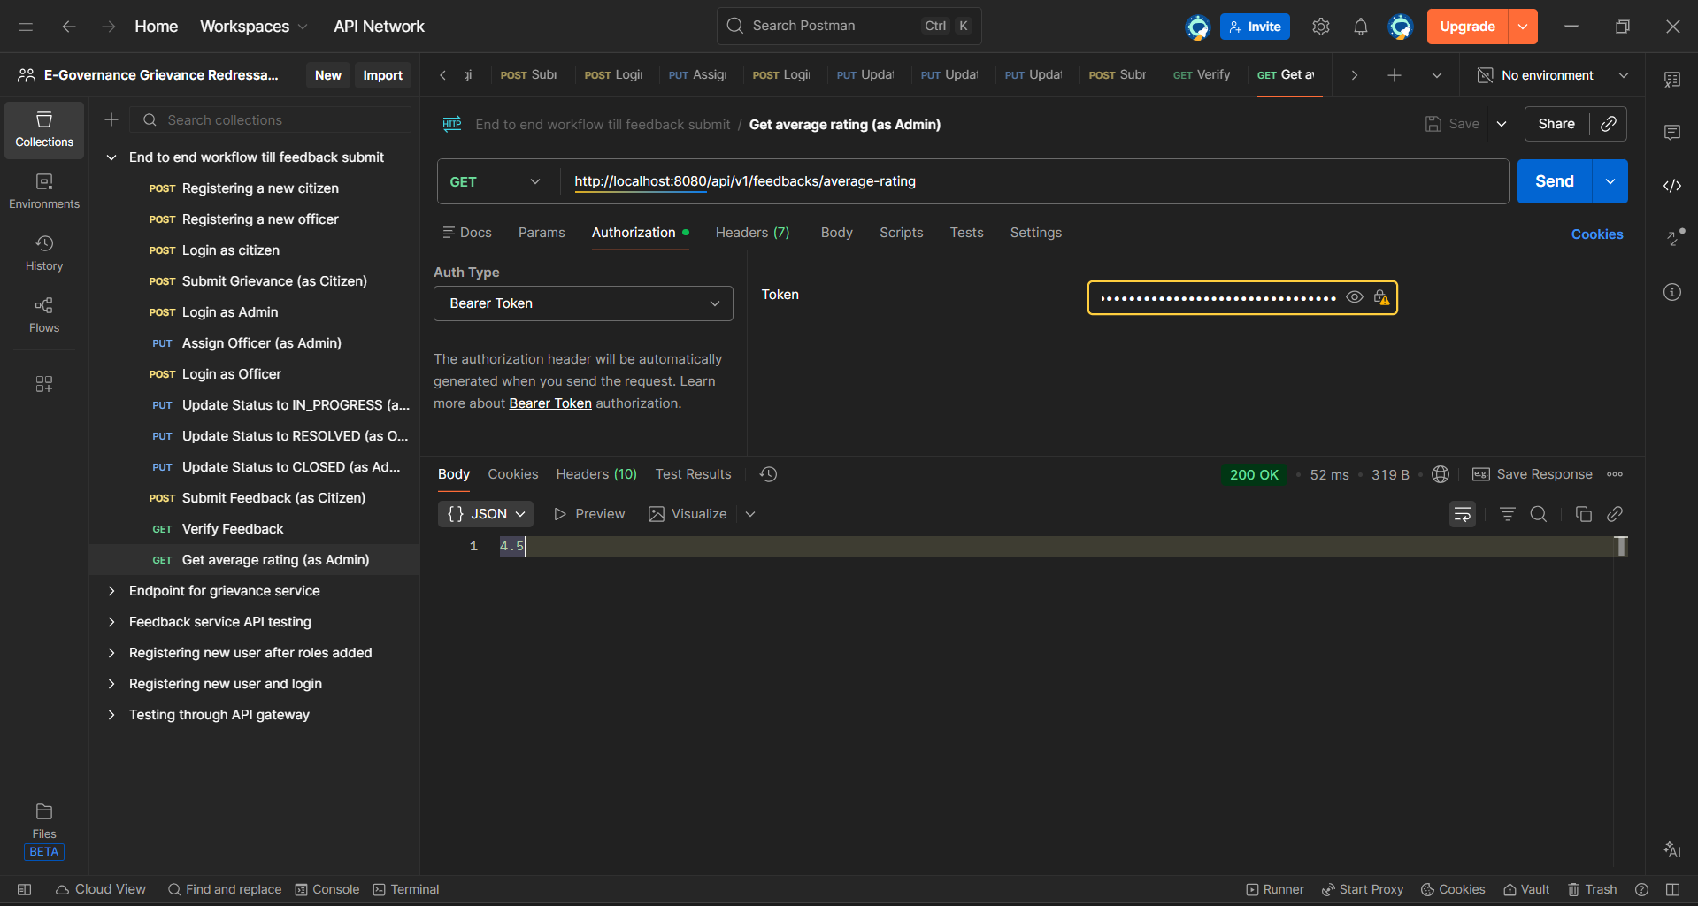

- Angular Frontend

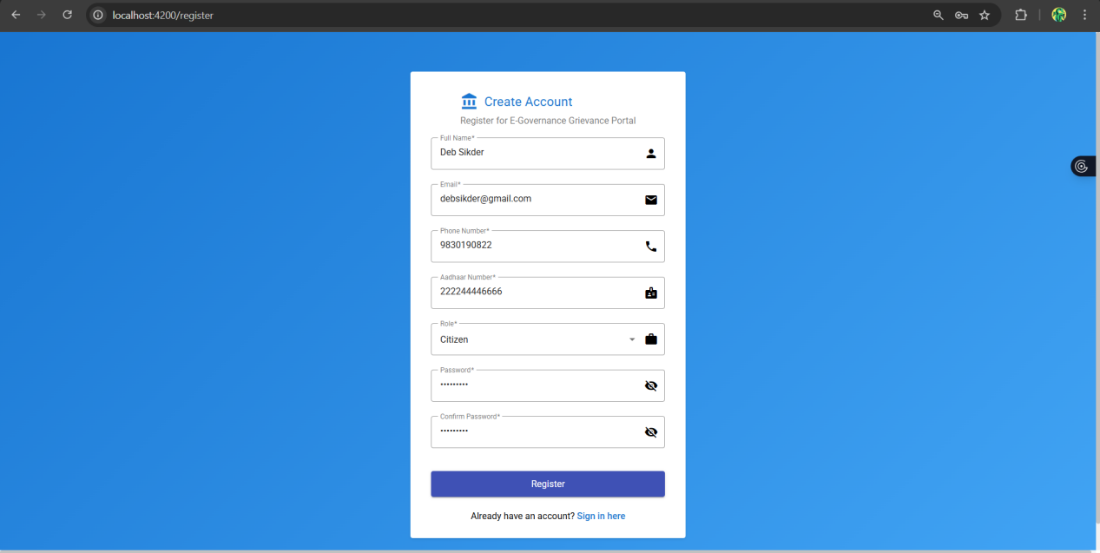

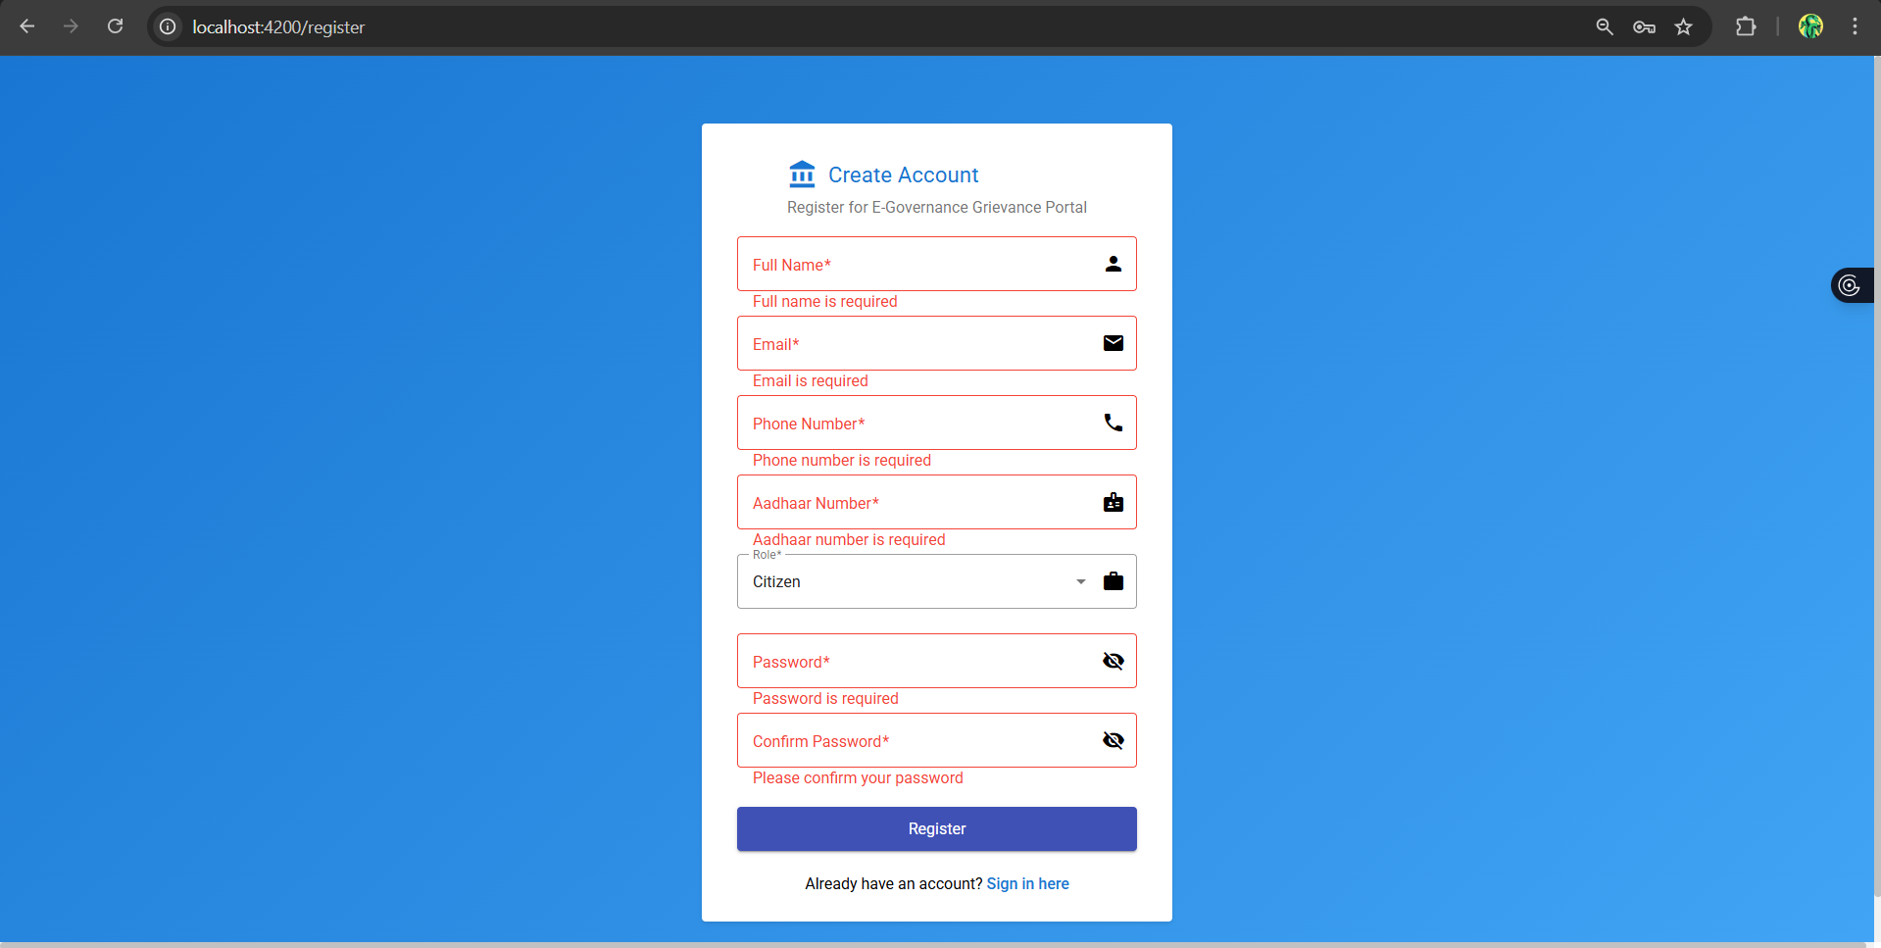

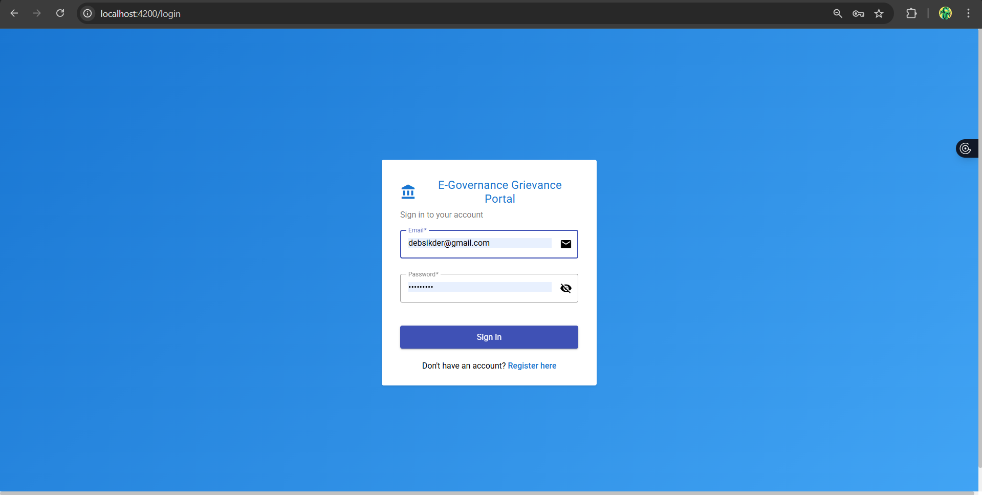

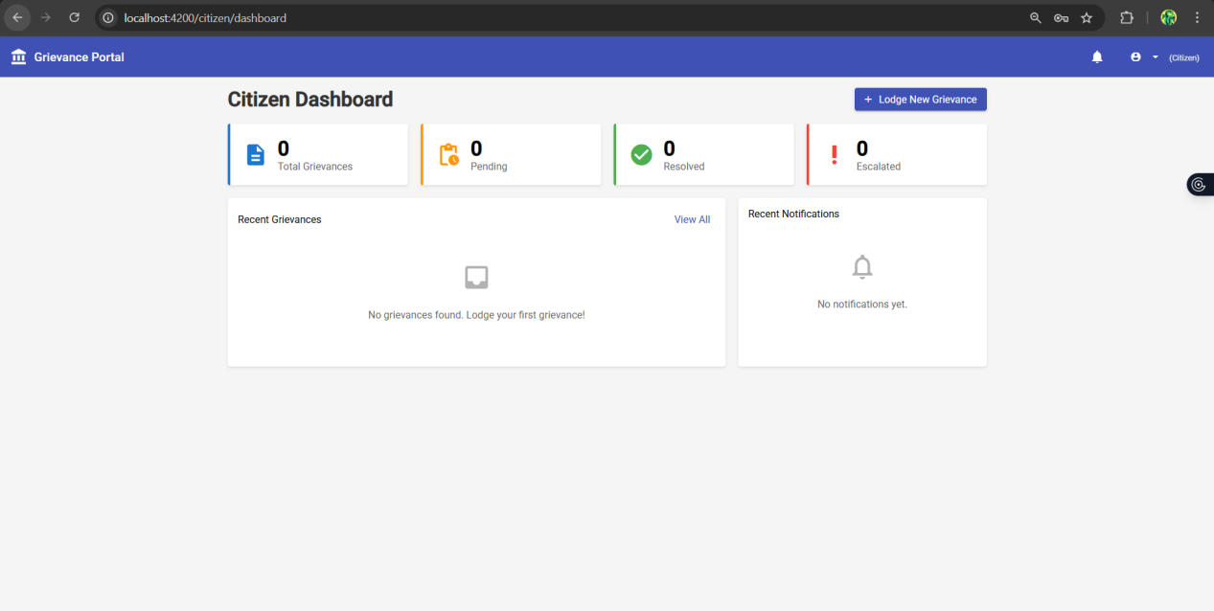

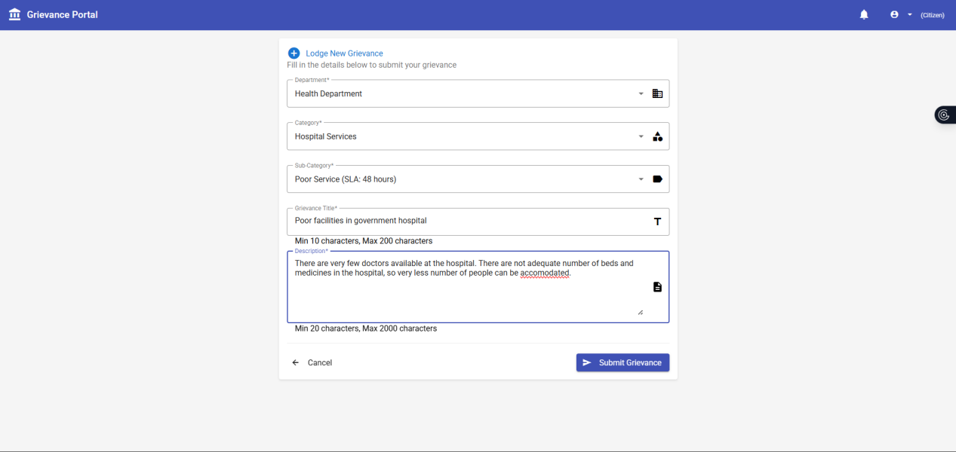
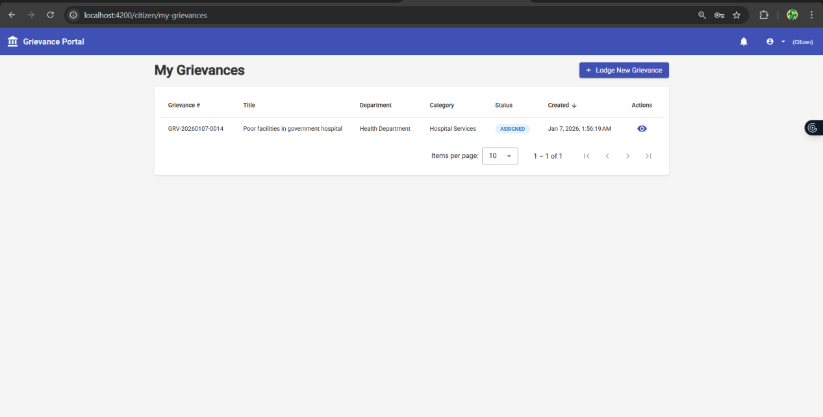

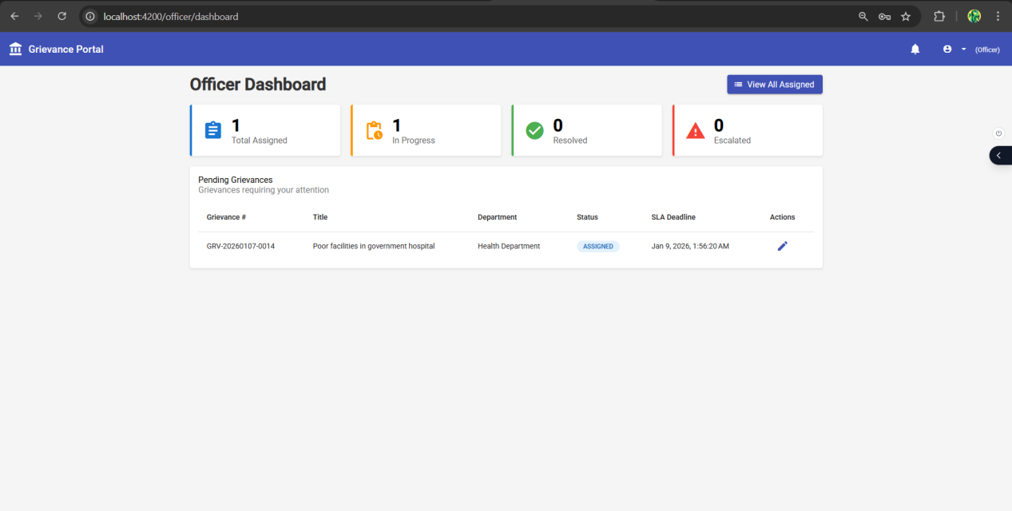

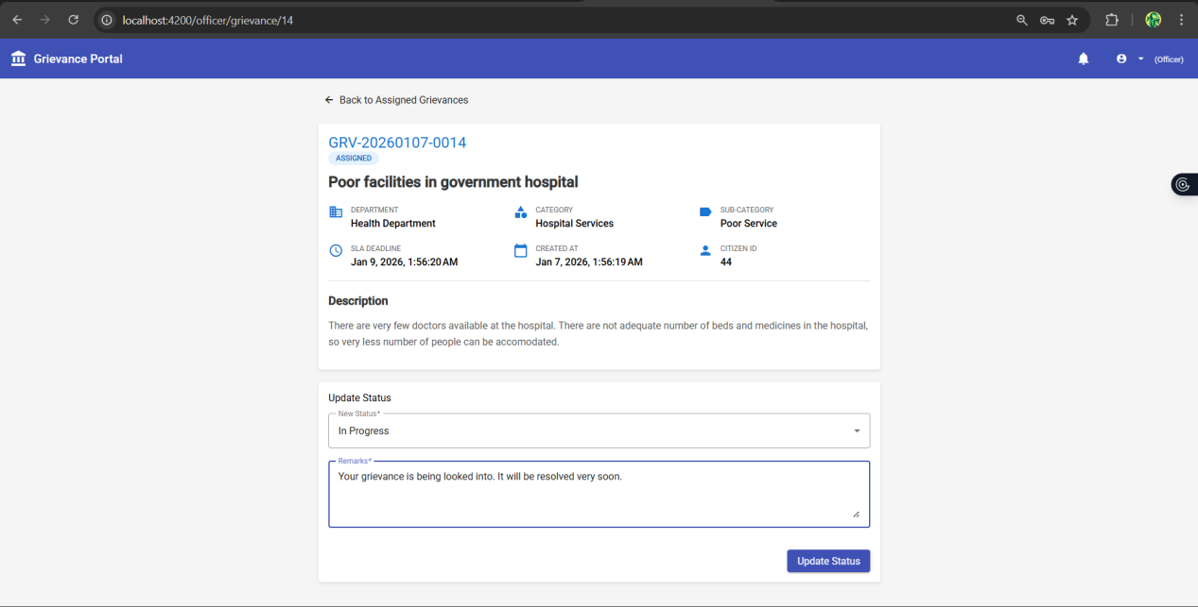

6. Postman Collections Overview - User View

6.1 User Login with Validations

Invalid Credentials Scenario
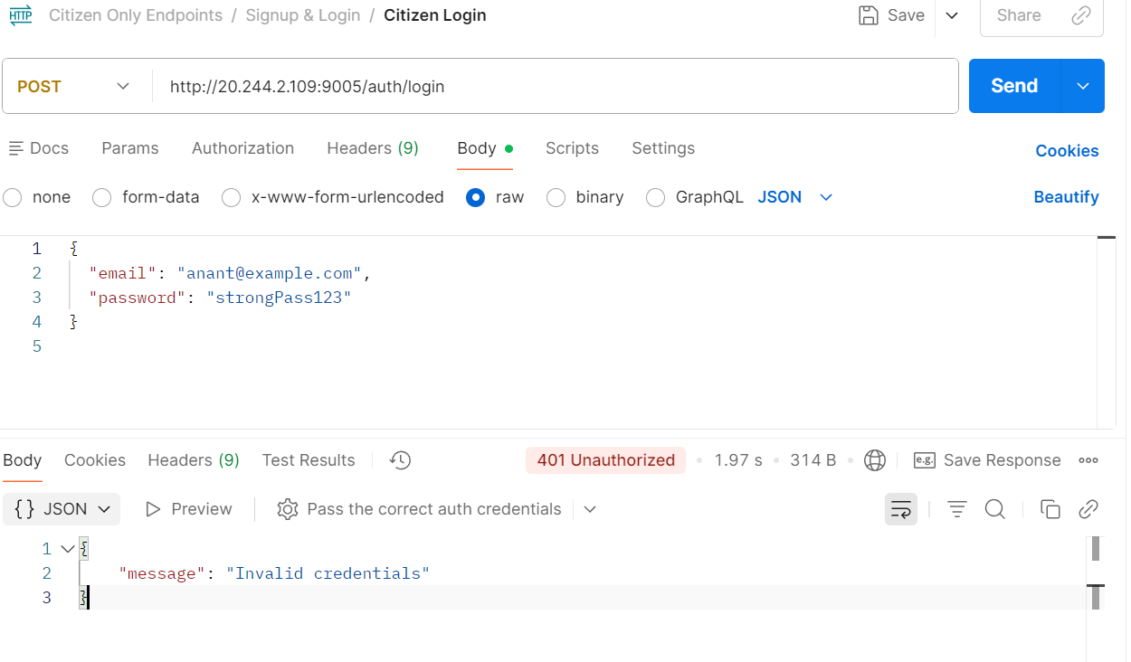

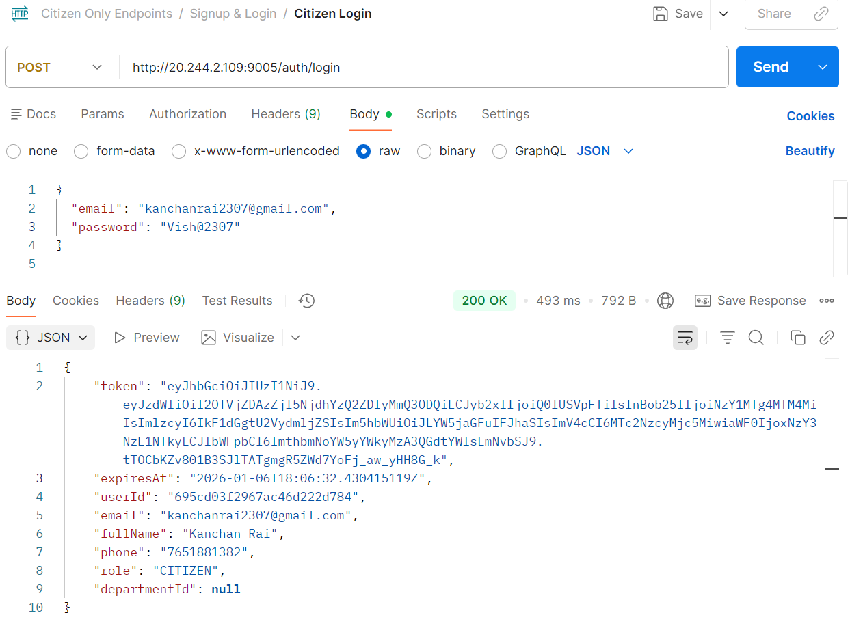
Valid Login

User Registration with Validation - User already exists
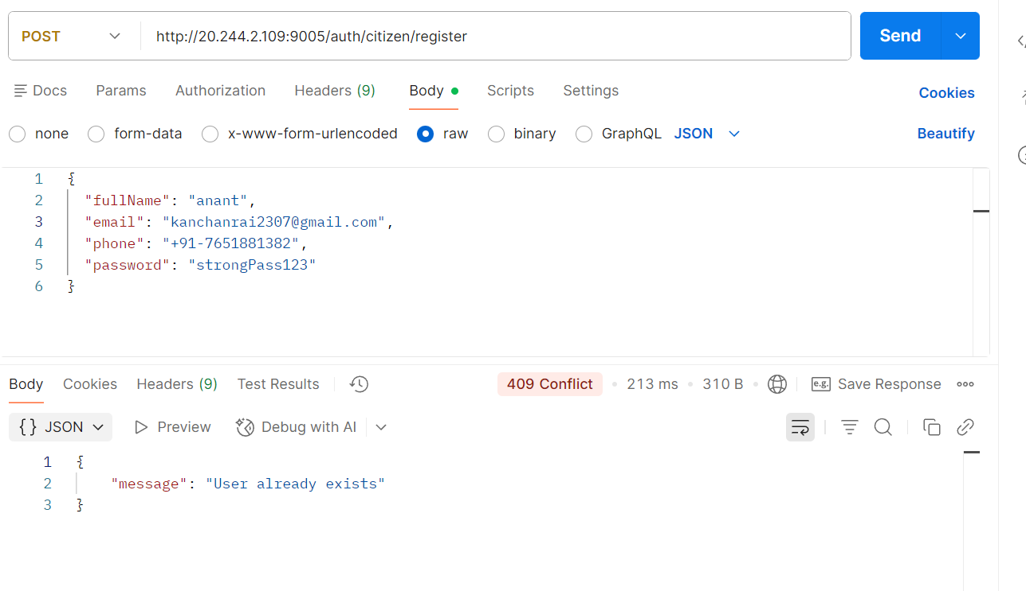

Successful User Creation
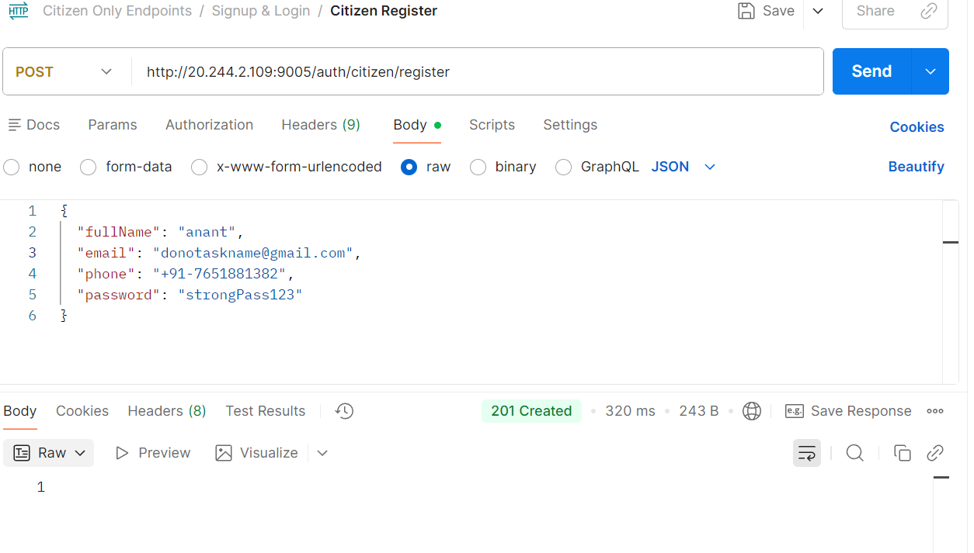

Lodging a grievance
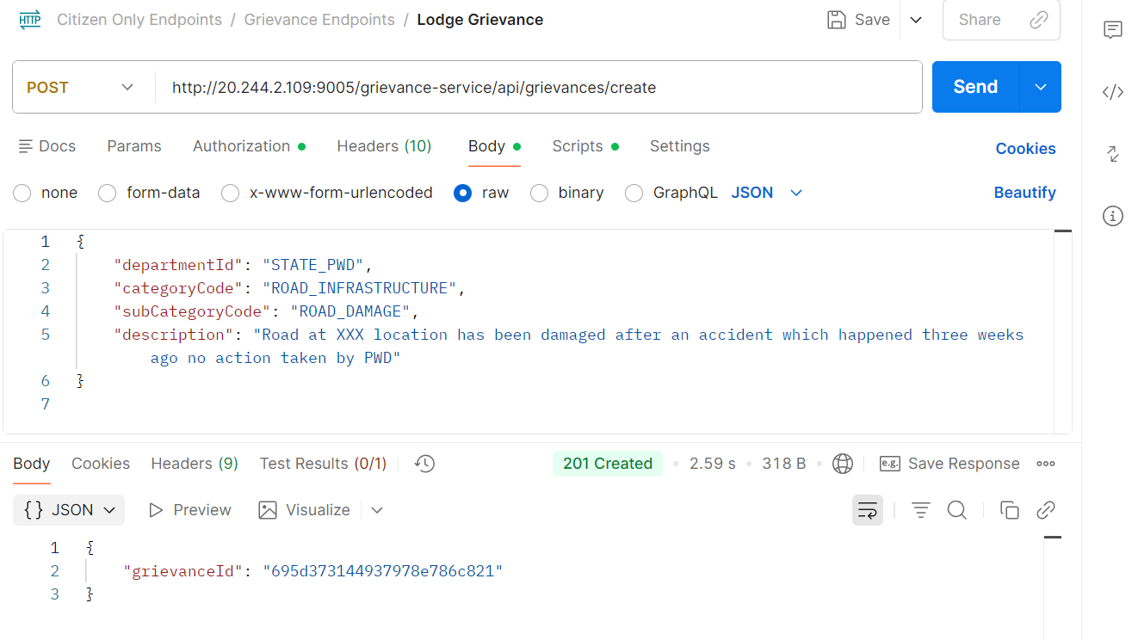

Checking the status
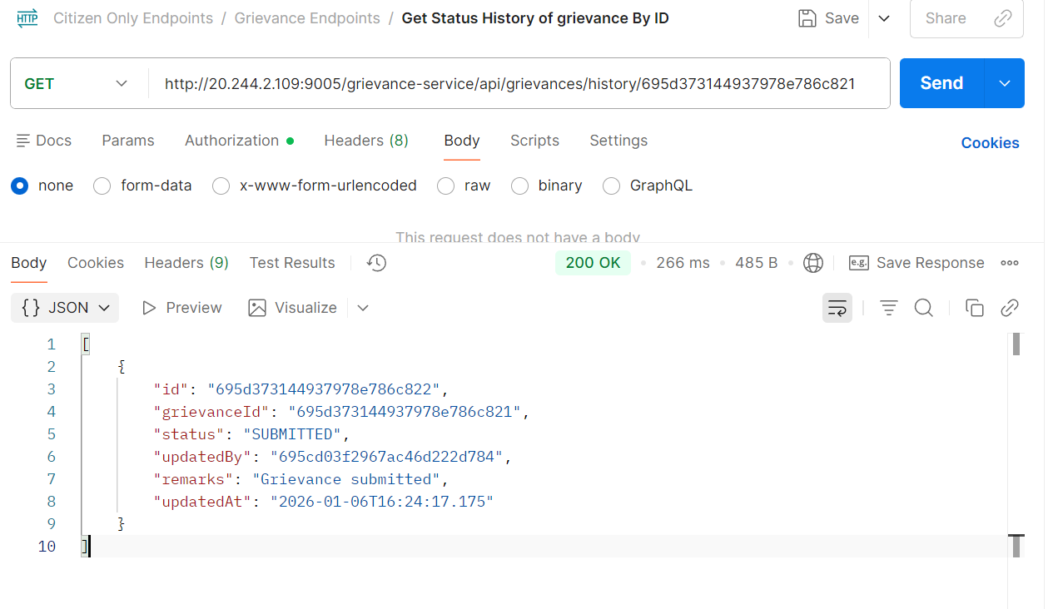

7. Angular Frontend

